23Jul26 - Macro Frozen Enhancement

1. Pick List

Objective
Improve the Pick List so warehouse staff can identify orders faster and reduce picking mistakes.

Business Problem
Current Pick Lists lack contextual information.
Warehouse staff currently need to infer:
- Which customer each line belongs to
- Which warehouse should fulfil the order (Warehouse names are more meaningful than internal codes)
- Special salesperson instructions (additional notes)
Remarks are also easy to miss because they appear at the bottom of the document.

Functional Requirements

1.1 Group Pick List - Detail Page
Warehouse Manager should be able to group Pick Lists on Web UI by:
- Customer
- Sales Order
- Warehouse

1.2 Additional Columns
Add the following to both Pick List table (UI) and Pick List PDF:
- Customer Name
- Additional Notes
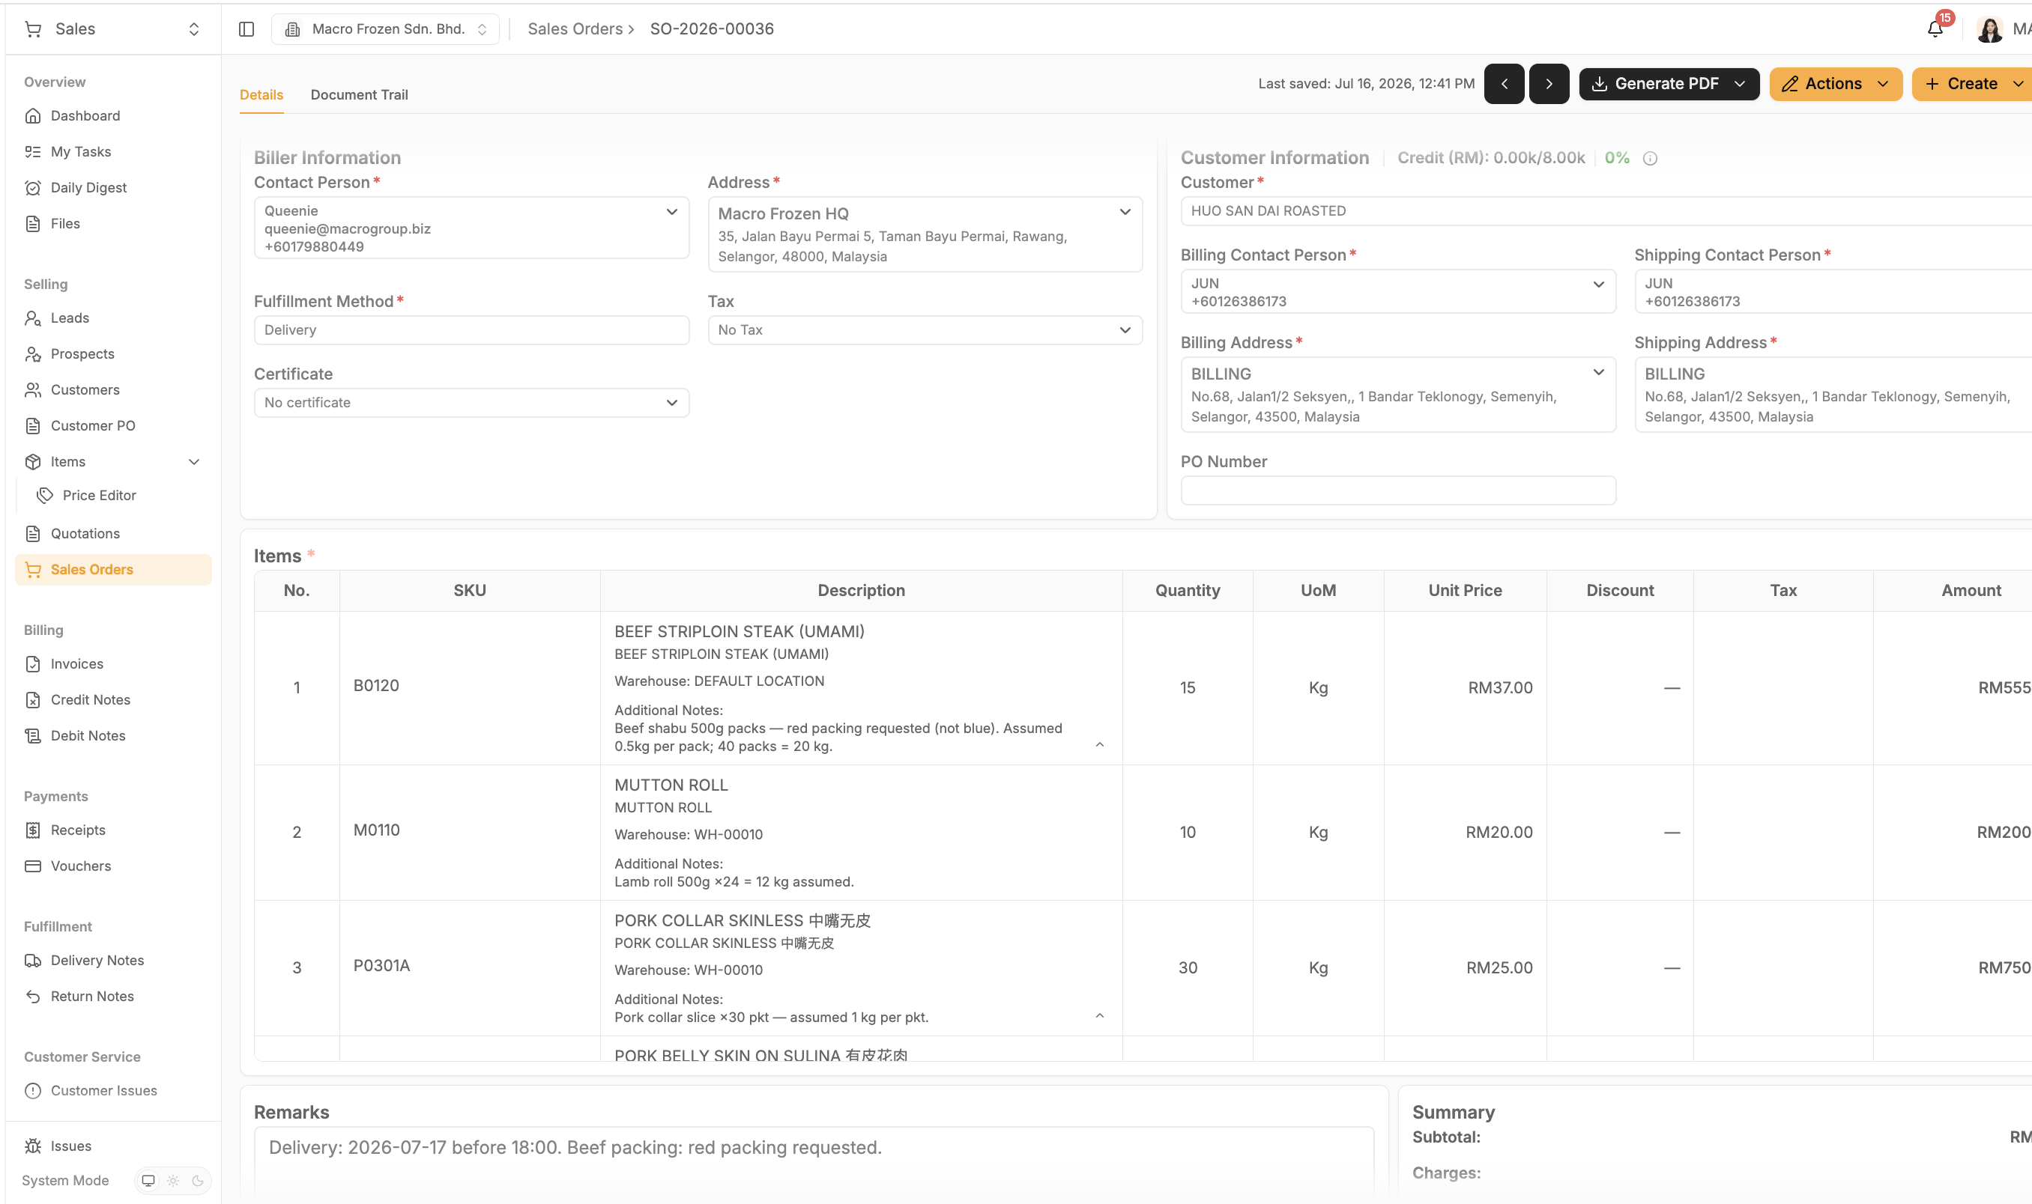

[Screen Recording 2026-07-23 at 6.16.06 PM.mov]
[Macrofrozen-Stock-Variance.mov]

1.3 Warehouse Display
In the Pick List PDF's Pick Scope section, display warehouse name, not warehouse code

1.4 Remarks Placement
Move Remarks section.
Current
Plain Text
Bottom of page
Expected
Plain Text
Top of page
Remarks:
Walk the warehouse top-to-bottom. At each stop pick the group total and write it in the Picked Qty box; note any shortfall in Remarks. Photograph this sheet and send to MAIA (<PL_id> must be visible).
Warehouse staff should see important instructions immediately.

1.5 Pick List
Workflow after MAIA:
- User attach packaging list to the pick list
- When DN generated,
- User manually split rows
- Print packaging list attachment and attch to the DN
- Packing list (backlog) if client insists on having packing list, will charge them as customisation
Suggested approach:
- Chatbot text based (11+12.5+13+12+12+.....=50kg)
- Excel processing
packging list 2026
CamScanner 06-08-2026 18.35.pdf
AGF INV2606-150.pdf
AGF D0-05012.pdf

2. Product Detail Screen

Objective
Simplify the Item Details screen for warehouse users.

Requirement
- Hide Purchasing Tab from the Item Detail page.
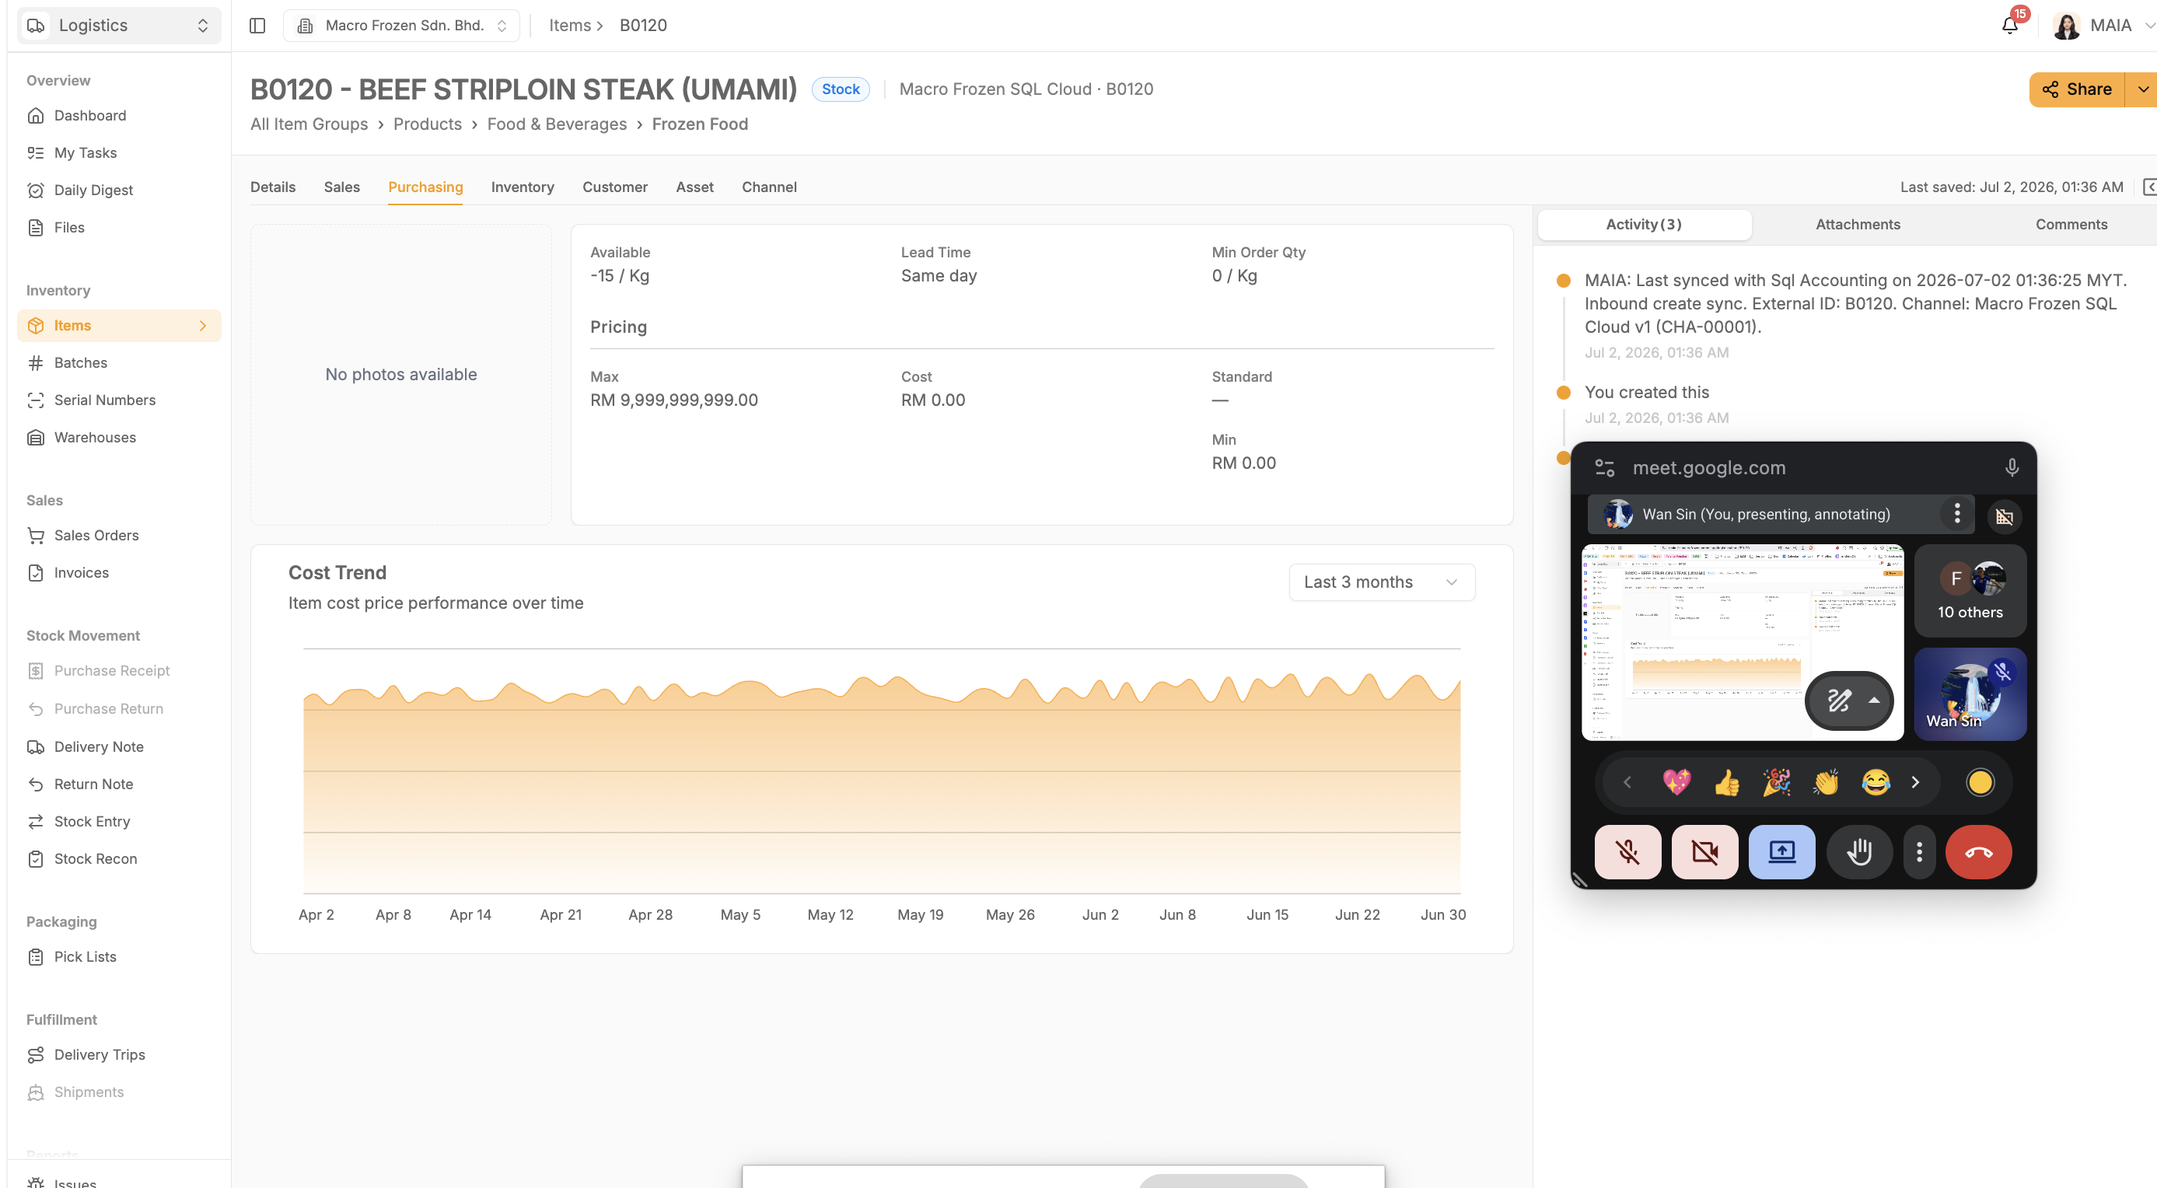

Rationale
- Warehouse users do not require purchasing information.
- Reduces visual clutter and accidental exposure of procurement data.

3. Lead / Prospect Improvements

3.1 CRM Notes for Leads

Requirement
Lead records should support CRM Notes as customers do.
After converting a lead to customer, CRN notes for such lead should be brought forward to the customer.

Rationale
- Sales interactions begin before a customer is created.
- Preserves engagement history throughout the sales lifecycle.

3.2 Hide Prospect Module
Requirements
- Hide the Prospect module.
- Hide the Lead → Prospect button on the lead details page.
- Adopt a simpler Lead → Customer workflow.
Rationale
- It is confusing to differentiate Leads and Prospects operationally.
- Removes an unnecessary CRM step and simplifies adoption.

3.3 Lead Merge

Requirements
- Detect existing customers during Lead conversion.
- Allow merging into the existing customer.
- Latest value takes precedence when conflicts occur.
- Merge
- CRM Notes
- Contact person
- Phone numbers
- Emails
- Address
- Company information

Rationale
- Prevents duplicate customer records.
- Preserves historical interactions while maintaining a single customer profile.

4. Credit Control Toggling Naming

Objective
Use consistent wording and logic.

Problem
The current customer-profile toggles are confusing because one is expressed positively and the other negatively.
Current concepts include:
- Bypass credit limit.
- Overdue block.

Requirement
- Credit limit enforced: Yes / No.
- Overdue block enabled: Yes / No.
Under this approach, “Yes” consistently means that the control is active.

5. Sales Dashboard Filter

Requirement
For David (owner) and CJ (Sales manager), Dashboard should support filtering by Salesperson.

6. Stock entry - out of scope
Supplier name is a required field
https://wiki.sql.com.my/wiki/Goods_Received

